**The Title Must Follow the Template in Both Font Type and Style [Article Titles Should be Between 10-15 words]**

***Author***1, ***Author***2, ***Author***3

1,2Name of Department or Faculty, University, Country

3Name of Department or Faculty, University, Country

1email, 2email, 3email

Received January 29, 2025; Revised March 12, 2025; Accepted July 07, 2025

**Abstract**

**Objective:** The purpose of this abstract is to serve as a guide for replicating the writing style required in this journal. **Theoretical framework:** The theoretical foundation of this template is based on the principles of observation, imitation, and modification. **Literature review:** The literature review in this template refers to previous studies, which have been adapted and modified by the creator to ensure novelty and distinctiveness. **Methods:** The writing method must follow a fully-justified, upright text format as shown below the author’s information. The word “Abstract” should be used as the title, centered above the text, in 11-point Times New Roman, boldface type. **Results:** The abstract content must be written in 11-point font size, single-spaced, and must not exceed 3 inches (18 picas or 7.62 cm) in length. One blank line should be left after the abstract before beginning the main text. **Implications:** The implication is that the abstract must be written in English, regardless of the language used in the main manuscript. **Novelty**: The abstract must include seven essential components, each marked in bold: 1. Objective, 2. Theoretical framework, 3. Literature review, 4. Methods, 5. Results, 6. Implications, and 7. Novelty/Originality. The total word count of the abstract should range between 333-355 words.

**Keywords:** 5 keywords, separated by commas, lowercase style, research, main words.

**INTRODUCTION**

Congratulations! Your paper has been accepted for journal publication. Please follow the steps outlined below when submitting your final draft to the JEISR. These guidelines include complete descriptions of the fonts, spacing, and related information for producing your proceedings manuscripts [1].

**LITERATURE REVIEW**

The literature review in this template refers to previous studies, which have been adapted and modified by the creator to ensure novelty and distinctiveness. Theories about the studies or themes studied and relevant previous research.

**METHODOLOGY**

All printed material, including text, illustrations, and charts, must be kept within the parameters of the 8 15/16-inch (53.75 picas) column length and 5 15/16-inch (36 picas) column width. Please do not write or print outside of the column parameters. Margins are 3.3cm on the left side, 3.65cm on the right, 2.03cm on the top, and 3.05cm on the bottom. Paper orientation on all pages should be in portrait style [2].

**RESULTS AND DISCUSSION**

The main title (on the first page) should begin 1 3/16 inches (7 picas) from the top edge of the page, centered, and in Times New Roman 14-point, boldface type and UPPERCASE [3].

**Tables**

Place tables as close as possible to the text they refer to and align the center. A table is labeled *Table* and given a number (*e.g.*, **Table 1. Table of Islamic Education Values and Meanings in the Peta Kapanca**) it should be numbered consecutively. The table label and caption or title appear 11pt space above the table, and 6pt space after the text or paragraph if any; it should be uniform fonts and font size, and use 11pt font size and Helvetica style, capitalized similarly to paper title, aligned center, and boldface. Sources and notes appear below the table, aligned left. All tables must be in portrait orientation [4].

**Table 1. Table Label**

|  |  |  |  |  |
| --- | --- | --- | --- | --- |
| **No** |  |  |  |  |
| **1** |  |  |  |  |
| **2** |  |  |  |  |
| **3** |  |  |  |  |
| **4** |  |  |  |  |

**Figures**

Place figures as close as possible to the text they refer to and align the center. Photos, graphs, charts, or diagrams should be labeled *Figure* (do not abbreviate) **and appear 6pt space below the figure, 11pt space before the next text or paragraph,** and assigned a number consecutively. The label and title should be in line with the figure number (*e.g.*, **Figure 1. Xxxxxx Xxxx Xxxxx**), it should be uniform fonts and font size; use 11pt font size and Helvetica style, capitalized similarly to the paper title, aligned center, and **boldface** [5].

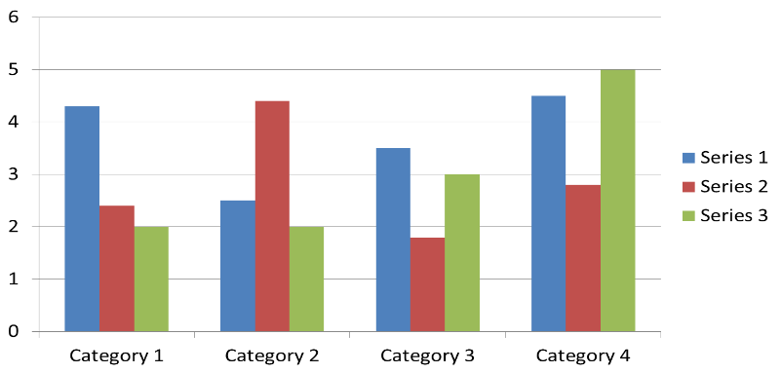

**Figure 1. Figure Label**

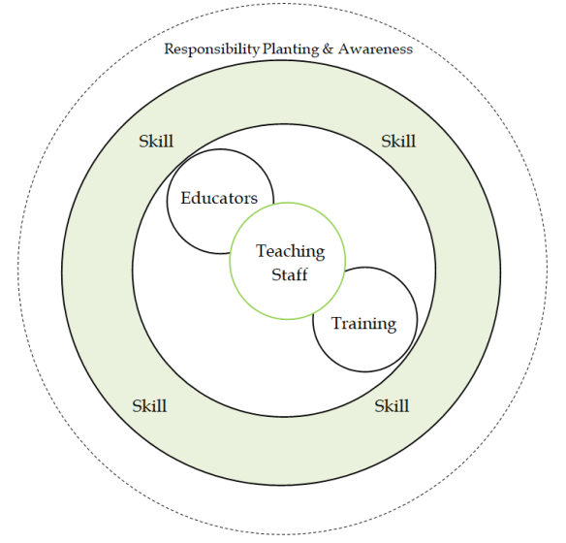

**Figure 2. Xx Xxxxxxx Xxxxx**

**Equations**

Including symbols and equations in the text, the variable name and style must be consistent with those in the equations. Equations should be indented at the left margin and numbered at the right margin, equation number is enclosed with open and close parenthesis () Time New Roman in style and 11pt font size. Deﬁne all symbols the ﬁrst time they are used. All equation symbols must be defined clearly and understandably.



**FIRST-ORDER HEADINGS**

For example, “**INTRODUCTION**”, should be in Times New Roman 12-point boldface, UPPERCASE, flush left, with one blank line before, and one blank line after.

**Second-order Headings (Sub-heading)**

As in this heading, they should be in Times New Roman 12-point boldface, initially Capitalized, flush left, with one blank line before, and one after.

**Third-order Headings:**

Third-order headings, as in this paragraph, are discouraged. However, if you must use them, use 11-point Times New Roman, boldface, initially Capitalized, flush left, and proceed by one blank line, followed by a colon and your text on the same line.

It should be noted, that manuscripts other than English can adapt this template. Use footnotes sparingly (or not at all) and place them at the bottom of the column of the page on which they are referenced. Use Times New Roman 9-point type, single-spaced. To help your readers, avoid using footnotes altogether and include necessary peripheral observations in the text (within parentheses, if you prefer, as in this sentence), for example [6].

**CONCLUSION**

Any comments and suggestions are welcomed so that we can constantly improve this template to satisfy all authors’ research needs.

**Acknowledgments**

We extend our heartfelt gratitude to the University of xxxxxx

**Author Contribution**

Awad Mark: Conceptualization, Methodology, Writing – review & editing, xxxxxx

**Conflicts of Interest**

The author declares no conflict of interest.

**REFERENCES**

List and number all bibliographical references that have important contributions to the paper, (if possible, a minimum of 40 references, which only are necessary citations are recommended). 9-point Times New Roman, fully justified, single-spaced, at the end of your paper. When referenced in the text, enclose the citation number in square brackets, for example [7]. Do not abbreviate the months. Don’t forget to put the period (.) at the end of each reference. (See examples below). **Do not use** the phrases **"et al."** and **"ibid."** in the references section. Instead, the names of all authors in a reference must be listed. **References must use the Mendeley system, (IEEE style)**. With the numerical system, references are arranged in the reference list so that they match the order in which they are cited in the text.

1. T. Van Waeyenberg, R. Peccei, and A. Decramer, “Performance management and teacher performance: the role of affective organizational commitment and exhaustion,” Int. J. Hum. Resour. Manag., vol. 33, no. 4, pp. 623–646, 2022, <https://doi.org/10.1080/09585192.2020.1754881>. (journal)
2. A. Mac Phail, M. Ulvik, A. Guberman, G. Czerniawski, H. Oolbekkink-Marchand, and Y. Bain, “The professional development of higher education-based teacher educators: needs and realities,” Prof. Dev. Educ., vol. 45, no. 5, pp. 848–861, 2019, <https://doi.org/10.1080/19415257.2018.1529610>. (journal)
3. R. Crawford, “Information technology in secondary schools and its impact on training information technology teachers,” J. Inf. Technol. Teach. Educ., vol. 9, no. 2, pp. 183–198, 2000, <https://doi.org/10.1080/14759390000200082>. (journal)
4. P. Pamungkas, M, “Social Level Parameters of Banjar Society in the Tradition of Jujuran Islamic Law Perspective,” in Proceedings of the International Conference on Engineering, Technology and Social Science (ICONETOS 2020), 2021, vol. 529, no. Iconetos 2020, pp. 87–90. (Conference)
5. H. S. Nawwal, “Magnetic Nanostructures”, American Scientific Publishers, Los Angeles, **(2023)**. (book)
6. H. V. Jansen, N. R. Tas, and J. W. Berenschot, “Encyclopedia of Nanoscience and Nanotechnology”, Edited H. S. Nalwa, American Scientific Publishers, Los Angeles, vol. 5, **(2024)**, pp. 163-275. (chapter in a book)
7. C. E. Larsen, R. Trip, and C. R. Johnson, “Methods for procedures related to the electrophysiology of the heart”, **(2024)**, <https://patentimages.storage.googleapis.com/00/d0/29/c2c9fb738c9e05/US5529067.pdf>. (website)