Islamic Values in the Tradition of Peta Kapanca Xxxxxxx Xxxxxxxxxxxxxxxx Xxxxxxx

Author^{1*}, Author², Author³
¹Name of Department, University, Country
²Name of Department, University, Country
³Name of Department, University, Country
^{1*}email, ²email, ³email

Article History: Received December 30, 2022; Revised January 12, 2023; Accepted January 07, 2023

Abstract: The abstract is to be in fully-justified italicized text as it is here, below the author information. Use the word “Abstract” as the title, in 11-point Times New Roman, boldface type, initially capitalized. The abstract is to be in 11-point, single-spaced type, and may be up to 3 in. (18 picas or 7.62 cm) long. Leave two blank lines after the abstract, and then begin the main text. Abstract must be in English, including manuscripts other than in English. Abstract must contain: Purpose of the study, Methodology, Main Findings, Novelty/Originality of the study.

Keywords: 3-5 keywords, comma between keywords.

INTRODUCTION
Congratulations! Your paper has been accepted for journal publication. Please follow the steps outlined below when submitting your final draft to the Profetika: Jurnal Studi Islam. These guidelines include complete descriptions of the fonts, spacing, and related information for producing your proceedings manuscripts. Please follow them and if you have any questions, direct them to the production editor in charge of your journal at the Profetika, profetika@ums.ac.id [1].

LITERATURE REVIEW
Theories about the studies or themes studied and relevant previous research.

METHODOLOGY
All printed material, including text, illustrations, and charts, must be kept within the parameters of the 8 15/16-inch (53.75 picas) column length and 5 15/16-inch (36 picas) column width. Please do not write or print outside of the column parameters. Margins are 3.3cm on the left side, 3.65cm on the right, 2.03cm on the top, and 3.05cm on the bottom. Paper orientation in all pages should be in portrait style [2].

RESULTS AND DISCUSSION
The main title (on the first page) should begin 1 3/16 inches (7 picas) from the top edge of the page, centered, and in Times New Roman 14-point, boldface type and UPPERCASE [3].

Tables
Place tables as close as possible to the text they refer to and aligned center. A table is labeled Table and given a number (e.g., Table 1. Table of Islamic Education Values and Meanings in the Peta Kapanca) it should be numbered consecutively. The table label and caption or title appears 11pt space above the table, 6pt space after the text or paragraph if any; it should be uniforms fonts and font size, and use 11pt font size and Helvetica style, capitalized similar to paper title, aligned center and bold face. Sources and notes appear below the table, aligned left. All tables must be in portrait orientation [4].
Table 1. Table Label
No
1
2
3
4

Figures
Place figures as close as possible to the text they refer to and aligned center. Photos, graphs, charts or diagram should be labeled Figure (do not abbreviate) and appear 6pt space below the figure, 11pt space before the next text or paragraph, and assigned a number consecutively. The label and title should be in line with the figure number (e.g., Figure 1. Four Muslim Majority Countries in Asia), it should be uniforms fonts and font size; use 11pt font size and Helvetica style, capitalized similar to paper title, aligned center and bold face. Source (if any) appear underneath, flush left. Figures should be at good enough quality. Minimum image dimensions are 6 cm (2.3622 in) wide by 6 cm (2.3622 in) high [5].
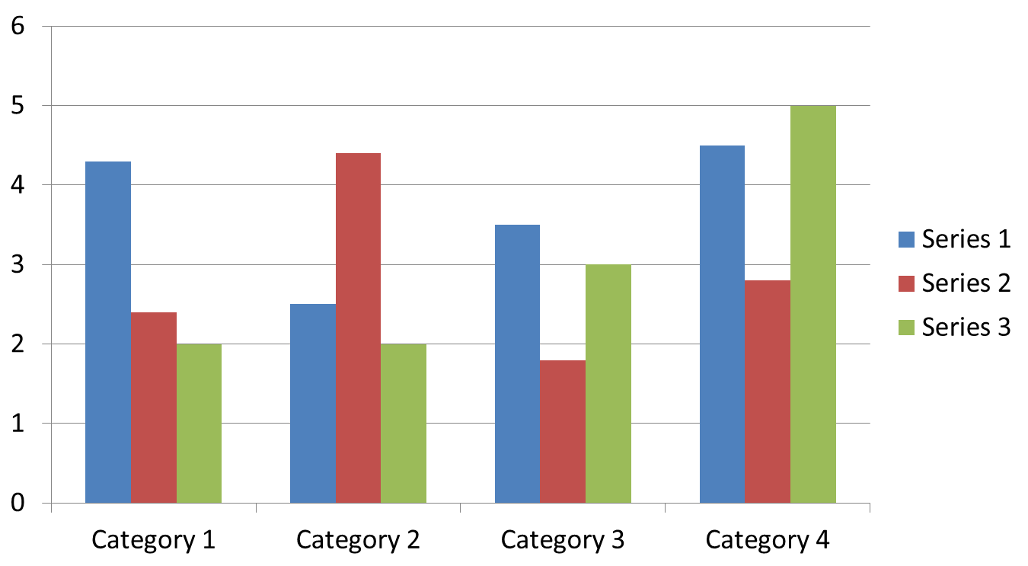

Figure 1. Figure Label
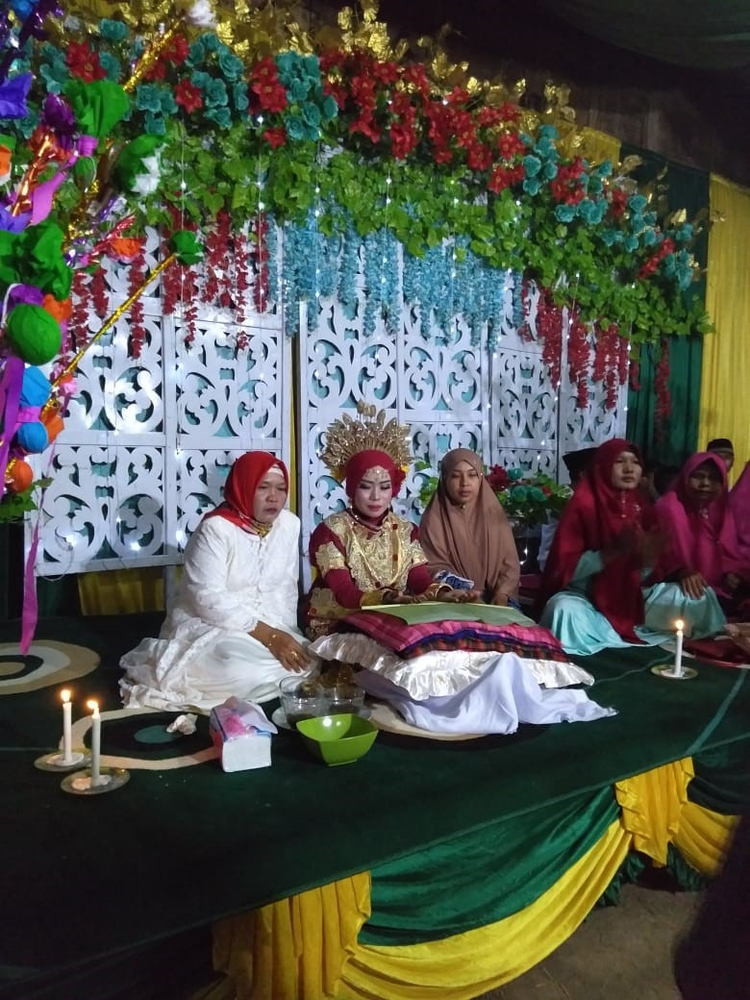

Figure 2. Procession
Equations
Including symbols and equations in the text, the variable name and style must be consistent with those in the equations. Equations should be indented at the left margin and numbered at the right margin, equation number is enclosed with open and close parenthesis () Time New Roman in style and 11pt font size. Deﬁne all symbols the ﬁrst time they are used. All equation symbols must be defined in a clear and understandable way.

FIRST-ORDER HEADINGS
For example, “INTRODUCTION”, should be Times New Roman 12-point boldface, UPPERCASE, flush left, with one blank line before, and one blank line after.

Second-order Headings (Sub-heading)
As in this heading, they should be Times New Roman 12-point boldface, initially Capitalized, flush left, with one blank line before, and one after.

Third-order Headings:
Third-order headings, as in this paragraph, are discouraged. However, if you must use them, use 11-point Times New Roman, boldface, initially Capitalized, flush left, and proceeded by one blank line, followed by a colon and your text on the same line.
It should be noted, manuscripts other than English can adapt this template.

FOOTNOTES
Use footnotes sparingly (or not at all) and place them at the bottom of the column of the page on which they are referenced to. Use Times New Roman 9-point type, single-spaced. To help your readers, avoid using footnotes altogether and include necessary peripheral observations in the text (within parentheses, if you prefer, as in this sentence), for example [1][2].

CONCLUSION
Any comments and suggestions are welcomed so that we can constantly improve this template to satisfy all authors’ research needs.

ACKNOWLEDGMENTS
These should be brief and placed at the end of the text before the references.

REFERENCES
List and number all bibliographical references that has important contribution on the paper, (if possible, limit to 30, which only are necessary citations are recommended). 9-point Times New Roman, fully justified, single-spaced, at the end of your paper. When referenced in the text, enclose the citation number in square brackets, for example[1]. Do not abbreviate the months. Don’t forget to put period (.) at the end of each reference. (See examples below). Do not use the phrases "et al." and "ibid." in the references section. Instead, the names of all authors in a references must be listed. References must use the Mendeley system. With the numerical system, references are arranged in the reference list so that they match the order in which they are cited in the text.

- S. A. R. Muthoifin, Sudarno Shobron, “Humanist Islam in Indonesia Ahmad Syafii Maarif perspective,” Humanit. Soc. Sci. Rev., vol. 7, no. 6, pp. 780–786, 2019. (journal)
- P. P. Muthoifin, “Social Level Parameters of Banjar Society in the Tradition of Jujuran Islamic Law Perspective,” in Proceedings of the International Conference on Engineering, Technology and Social Science (ICONETOS 2020), 2021, vol. 529, no. Iconetos 2020, pp. 87–90. (conference)
- H. S. Nalwa, “Magnetic Nanostructures”, American Scientific Publishers, Los Angeles, (2003). (book)
- H. V. Jansen, N. R. Tas and J. W. Berenschot, “Encyclopedia of Nanoscience and Nanotechnology”, Edited H. S. Nalwa, American Scientific Publishers, Los Angeles, vol. 5, (2004), pp. 163-275. (chapter in book)
- C. E. Larsen, R. Trip and C. R. Johnson, “Methods for procedures related to the electrophysiology of the heart”, (1995), https://patentimages.storage.googleapis.com/00/d0/29/c2c9fb738c9e05/US5529067.pdf. (website)

